**Predicting Appropriate ICD Therapies with Daily Remote Home Monitoring in the IMPACT Trial:**

*A comparison of classical versus machine-learning based approaches*

Curtis Ginder, MD, MBAa Warren Mo,b Roderick Tung, MD,c Ishanu Chattopadhyay, PhD,d and Gaurav A. Upadhyay, MD,c

*aDepartment of Internal Medcine, Brigham and Women’s Hospital, Harvard Medical School, Boston, MA, USA; bZero Knowledge Discovery Group, The University of Chicago; cCenter for Arrhythmia Care, Heart and Vascular Institute, The University of Chicago Pritzker School of Medicine, Chicago, IL, USA; dDepartment of Hospital Medicine, The University of Chicago Pritzker School of Medcine, Chicago, IL, USA*

*Word Count*: XXX

*Funding*: Curtis Ginder was supported by the University of Chicago Catherine Dobson Prize

*Disclosures*: Dr. Ginder, Warren Mo, and Dr. Chattopadhyay report no relevant disclosures. Dr. Roderick Tung has been on the advisory board for Abbott and Boston Scientific. Dr. Gaurav Upadhyay has been a consultant for Abbott, Biotronik and Medtronic.

*Correspondence*:

Gaurav A. Upadhyay, MD

Assistant Professor of Medicine

Heart and Vascular Institute

The University of Chicago Pritzker School of Medicine

5841 S. Maryland Avenue MC 9024

Chicago, IL 60637

upadhyay@uchicago.edu

Tel: 773.702.5988

Fax: 773.702.4666

**ABSTRACT**

**Background**: Although device-based diagnostics have been utilized to predict heart failure (HF) hospitalization, prediction of ventricular fibrillation (VF) or sustained ventricular tachycardia (VT) requiring therapy has remained elusive. We sought to compare classical versus machine-learning approaches for shock prediction.

**Methods**:This was a post-hoc analysis of the IMPACT trial, a study enrolling HF patients receiving either implantable cardioverter-defibrillator (ICD) or cardiac resynchronization therapy with defibrillator (CRT-D) devices. Device therapies were adjudicated as either appropriate (for ventricular arrhythmias) or inappropriate (all others). Remote monitoring data in the 30 days prior to device therapy were utilized to develop a multivariate logistic regression model and machine-based model to predict appropriate device therapies. Model performance was compared using c-statistic and confusion matrices.

**Results**: A total of 59,807 device transmissions for 2,347 patients (Age 64±11 years, 26% female, 64% ICD) were collected. Appropriate device therapy was delivered to 151 patients. In multivariate logistic regression, shock lead impedance, ventricular ectopy and non-sinus rhythm conduction were significantly associated with increased risk of appropriate device therapy (SN 41%, SP 90%, PPV 22%). Machine-learning importance assessment (SN 43%, SP80%, PPV13%) further identified significance for patterns of change in atrial and right ventricle impedance. Both logistic regression and random forest models yielded similar predictive performance (c-statistic 0.74 vs 0.70, respectively).

**Conclusions**

Real-time remote monitoring data may be utilized to predict appropriate ICD shocks or ATP in the 24 hours prior to therapy. Machine-learning complements classical approaches and identifies novel variables of interest.

*Abbreviations:*

Implantable cardioverter defibrillator = (ICD)

Cardiac resynchronization therapy with defibrillator (CRT-D)

Antitachycardia Pacing = (ATP)

Coronary Artery Disease = (CAD)

Sensitivity = (SN)

Specificity = (SP)

Positive predictive value (PPV)

**Introduction**

Appropriate and inappropriate ICD shocks have been associated with increased risk of morbidity, mortality, and acute decompensated heart failure hospitalizations in addition to significant detriment on quality of life.[1-3] ICDs are highly effective in the primary and secondary prevention of sudden cardiac death due to ventricular arrhythmias but offer limited insight into the underlying disease process driving arrhythmias and subsequent shocks.[7-9] While the risk of inappropriate ICD therapy may be partially mitigated by careful device parameter setting, the prediction and modification of risk for ventricular arrhythmias and subsequent appropriate ICD therapy remains challenging. [10]

Previous efforts to predict risk of ventricular arrhythmias have largely resulted in static models that utilize historical clinical information, including baseline clinical diagnoses and demographic data.[11-13] Modern generation ICDs are now capable of measuring and storing physiologic variables including heart rate, impedance levels, and patient activity levels that may yield additional information beyond these static measures. While this real-time data has been demonstrated useful in the prediction of mortality and risk of HF hospitalization, similar efforts to identify patients at risk of pending ventricular arrhythmias are lacking, and no dynamic risk stratification models are available to clinicians to predict possible ICD shocks. [14, 15] The prediction of patients at risk of VT and VF using a continuously updated risk calculation could create opportunities for clinicians to intervene on underlying pathology to prevent arrhythmias along with the morbidity from shocks themselves.

Recent advances in artificial intelligence (AI) might allow for better utilization of the quantity of data captured by ICDs to improve dynamic prediction of ventricular arrhythmia risk. Applications of machine learning and AI in medicine have yielded models that approximate the capabilities of cardiologists in diagnosing arrhythmias on twelve-lead ECG, sub-classify phenotypes of heart failure, predict coronary artery disease mortality, and diagnose hyperkalemia on an ECG.[16-19] This growing trend represents opportunities for cardiologists to incorporate decision support and diagnostic assistance from AI techniques.[20, 21] The non-linear nature of machine learning algorithms may allow for improved event prediction over traditional linear regression. Further, novel methodologies of interpreting machine learning models may allow for the identification of clinical variables that are relevant for the prediction of arrhythmia but are not readily apparent using traditional linear regression.[22]

We sought to evaluate whether daily remote monitoring data collected by ICD and CRT devices could be used to predict appropriate ICD therapy for ventricular arrhythmias. Further, we sought to compare classical traditional logistic regression to machine-learning approaches for event prediction to evaluate whether computational approaches might identify novel variables of interest.

**Methods**

This was a post-hoc analysis of the IMPACT study, a multicenter randomized trial of 2718 heart failure patients evaluating atrial tachyarrhythmias and anticoagulation for patients with ICD and CRT-D devices.[23] Home monitoring data and device electrograms (EGMs) were obtained for all patients enrolled in the IMPACT study. Baseline demographic information, medical history, and medications were obtained for patients at the time of study enrollment. For patients receiving ICD shocks or antitachycardia pacing (ATP) during the trial, EGMs at the time of first device therapy were obtained. Two blinded reviewers independently adjudicated each EGM into one of three categories: 1) “Appropriate” therapies (either shocks or ATP) for ventricular fibrillation or sustained ventricular tachycardia, 2) “Inappropriate” therapies for supraventricular arrhythmias such as atrial fibrillation, atrial flutter, or other supraventricular tachyarrhythmias (SVTs), or 3) “Excluded” therapies which included exclusions for device error (e.g., T-wave oversensing, double counting QRS, or far-field sensing), external magnetic interference, lead malfunction, or incorrect EGM transmission (e.g., nonsustained arrhythmias or sinus rhythm transmitted before device therapy). Patients with excluded EGMs were removed from subsequent analysis. Patients who did not receive any device therapy throughout the trial were included as control patients. Differences in baseline demographic variables between each adjudication group were assessed using chi-squared and ANOVA testing.

For patients receiving appropriate device therapy, 30 days of home monitoring data prior to the index episode of device therapy were obtained. For control patients, 30 days of home monitoring data prior to the midpoint of each patient’s study enrollment were obtained. For patients with multiple home monitoring transmissions in a single day, the transmission with the longest duration of monitoring was included and all other transmissions for that date were discarded. Due to variability in home monitoring transmission timing, home monitoring periods that concluded prior to 8:00 am were determined to reflect the date prior to the transmission. Home monitoring data that occurred on the date of device therapy were excluded due to poor data reliability related to device therapy and subsequent medical attention. Patients without home monitoring data were excluded from analysis.

Time Series Analysis: Logistic Regression

For each continuous device diagnostic variable, mean values for each adjudication group were calculated for each day prior to device therapy or enrollment midpoint for appropriately treated and control patients, respectively. Each variable was evaluated for trends in mean values by adjudication group prior to device therapy. Cut-points in the integral change in a variable prior to therapy were determined using ROC analysis. An example of this procedure applied to Daily Mean Atrial Heart Rate is displayed in **Supplemental Figures** **1-4**. For variable data stored as counts (e.g., cumulative episodes of device detected ventricular fibrillation), any increase in the variable count during the three days prior to therapy or enrollment midpoint was included as a cut-point.

Patients were then split into training (60%) and validation (40%) data samples using in-block randomization. Univariate logistic regression modeling the prediction of appropriate device therapy was conducted for each demographic and device diagnostic cut-point indicator variable. Significant univariate predictors of device therapy were included in a backwards stepwise logistic regression model with selection by AIC. Patients with missing cut-point data were removed prior to the development of the training model. In-sample and out-of-sample model performances were assessed with ROC analysis and classification tables using a predicted probability of device therapy event of 10%.

Time Series Analysis: Machine-Based Approach

The in-block randomization training and validation group assignments used for logistic regression were also used for modeling the prediction of appropriate device therapy with random forests. To address class imbalance, cases of appropriate shock were up-sampled in the training group. Feature creation was performed by _____________. The model was trained by maximizing in-sample F1 score ___________

Logistic Regression and Machine-Based Model Comparison

In-sample and out-of-sample model performances were assessed using ROC analysis and classification tables with sensitivity (SN), specificity (SP), and positive predictive values (PPV) calculated for each model. To qualitatively compare variables utilized by each model, variables remaining significant in multivariate logistic regression and internal estimates of variable importance using random forests were selected.

Data analysis was performed in R Studio 1.0.143 (RStudio, Inc.; Boston, MA) and Python 3.6.3 (Python Software Foundation; Wilmington, DE).

**RESULTS**

Baseline demographic data were obtained for 2,718 patients enrolled in IMPACT and are displayed in **Table 1**. There was a high rate of hypertension (84%) and heart failure (90%) for patients enrolled. Mean trial enrollment in the study was 735 days with a mean of 612 device transmission days, corresponding to an 84% transmission compliance rate. There were a total of 377 patients receiving device therapies for which EGMs were available for 310. Among patients with EGMs available, appropriate therapies occurred in 151 (48.7%), 73 (23.5%) were inappropriate therapies, and the remainder were excluded (86 patients or 27.8%). Reasons for EGM exclusion included incorrect EGM transmission (32 patients, 37.2%), T-wave oversensing (28 patients, 32.6%), far-field sensing or device noise (9 patients, 10.4%), lead or device malfunction (6 patients, 6.9%), external magnetic interference (4 patients, 4.7%), atrial conduction oversensing (3 patients, 3.4%), missing home monitoring data (3 patients 3.4%), or electrocautery (2 patients, 2.3%). A total of 2,341 patients did not receive device therapy and were included as control patients.

Baseline patient demographic data by adjudication group is displayed in **Table 2**. Patients who received inappropriate device therapy were younger on average and had lower home monitoring transmission compliance, while control patients were less likely to have a history of atrial fibrillation. Patients who received appropriate therapy were more likely to be prescribed an antiarrhythmic at time of trial enrollment.

Thirty-day device diagnostic data was obtained for 2347 patients. A total of 59,807 transmissions remained after data standardization, representing an average of 25.5 daily transmissions per patient. Cut-points were selected for 20 variables in the prediction of appropriate device therapy (see **Supplemental Table 1**). In the univariate prediction of events, increases in device detected ventricular ectopy (OR 3.0, p-value < 0.01), device detected VT episodes (OR 8.6, p-value <0.01), and device detected VF episodes (OR 24.1, p-value <0.01) were associated with an increased risk of appropriate device therapy. Similarly, increases in PP variability (OR 1.8, p-value 0.02) and a decrease in shock-lead impedance (OR 2.2, p-value < 0.01) were also associated with increased risk of appropriate therapy. With respect to baseline covariates, male gender (OR 2.1, p-value <0.01) and a history of atrial arrhythmia (OR 2.02, p-value 0.01) were also associated with an increased risk. Complete evaluation of univariate predictors of appropriate device therapy are presented **Supplemental Table 3**

In stepwise multivariate regression, seven device diagnostic and two demographic variables remained in the model, displayed in **Table 3**. Data from 992 patients in the training data set had complete records for the retained variables and were included in the creation of the multivariate model. Device detected VT and VF event counts (OR 12.6, p-value < 0.01, OR 18.8, p-value <0.01, respectively) portended the greatest risk of appropriate therapy, while the percentage of ventricular ectopy (OR 3.2, p-value <0.01) carried the highest odds ratio among continuous device variables.

Data from 1268 patients were used in the training of the random forest model. Hyperparameter tuning for random forest modeling resulted in a max tree depth of 1 node. After tuning, each tree had access to three days of data for each feature subtracted from the mean value for each patient.

Model Performance and Comparison

Model performance was assessed using a 40% hold-out validation dataset. Logistic regression and random forest modeling resulted in in-sample (IS) AUC values of 0.82 and 0.83, respectively, with corresponding out-of-sample (OOS) AUC values of 0.74 and 0.70. Both IS and OOS models had high negative predictive value of pending device therapy with a corresponding out-of-sample accuracy of 87% with logistic regression and 77% with random forests. ROC plots and model performance statistics are displayed in **Figure 1** and **Table 4**.

Final multivariate logistic regression and random forest models incorporated the percentage of monitored beats in sinus rhythm and percentage of ventricular ectopy in addition to device-detected VF events. Random Forest modeling separately identified right atrial (RA) pacing impedance, right ventricular (RV) pacing impedance, and transmission compliance as important variables in the prediction of events, while multivariate logistic regression found a history of atrial arrhythmia and shock lead impedance as statistically significant variables. A qualitative comparison of the variables utilized by each model is displayed in **Table 5**.

Placeholder paragraph for ROC discussion.

**Discussion**

In this retrospective analysis of the IMPACT trial evaluating 2718 patients receiving ICD therapy over 310 recorded device events, we found that real time remote monitoring data may be utilized to predict appropriate ICD shocks or ATP for VT/VF in the 24 hours prior to device therapy. Predictive performance was similar between logistic regression and machine learning methodology. While both models identified increasing measures of ventricular ectopy as important variables in the prediction of events, each model identified different subsets of variables as relevant for event prediction.

Within-patient changes in device collected variables are associated with an increased risk of ventricular arrhythmias and appropriate device therapy. Increasing ventricular ectopy and device detected episodes of VT and VF may be predictive of impending ICD therapy. These findings are consistent with previous work that has demonstrated an association between other markers of ventricular ectopy such as premature ventricular contractions and non-sustained ventricular tachycardia with a small but significant increased risk of sudden cardiac death. [24, 25] Additionally, a decrease in shock lead impedance was associated with an increased risk of device therapy. Decreases in intrathoracic impedance have been shown to inversely correlate with hemodynamic status and worsening heart failure.[26] Accordingly, this finding may signify an important marker of risk that clinicians are able to intervene upon to prevent ventricular arrhythmias from occurring.

Our findings suggest that in a relatively small dataset, a random forest modeling technique may be used to predict patients at risk for ventricular arrhythmias and complement classic statistical approaches for prediction. Interestingly, random forest variable importance analysis recognized measures such as RA and RV pacing impedance that were not statistically significant under univariate or multivariate logistic regression as relevant variables for the prediction of device therapy. Random forest modeling may better account for the complex, time-varying relationship between these non-physiologic measures. Utilizing non-linear modeling may allow for the identification of variables that are physiologically relevant but without intuitive patterns to predict device therapy. It may be possible to integrate both traditional logistic regression with random forest modeling to yield improved predictive performance and help direct further understanding of physiologic patterns. Similarly, we anticipate improved predictive capabilities with access to additional training data and with further specification of feature generation and hyper-parameter tuning.

This is the first study to our knowledge that describes the use of machine learning techniques to identify patients at risk of VT/VF prior to arrhythmia initiation, and contributes to the ongoing development of AI applications in cardiology. Previously, imaging data from echocardiography and measurements derived from standard twelve lead electrocardiograms (ECG) have been used to predict future risk of VT/VF, identifying changes in HR Variability, T-wave morphology, and QRS intervals as important predictors.[27-33] A smaller subset of work has evaluated changes in device or telemetry collected parameters prior to ventricular arrhythmias.[34-36] One study by Jedrzejczyk-Patj et al. examined recipients of cardiac resynchronization therapy and discovered significant variations in heart rate and thoracic impedance in the days leading up to ventricular arrhythmia.[37]

Dynamic risk prediction afforded by real time device data may offer the ability to identify patients at risk of future ventricular arrhythmia. With a negative predictive value of 96% and correct classification rate of 87%, our model was highly effective at excluding patients at a low risk of appropriate device therapy. Future extensions of this work could enable clinicians to closely monitor patients identified as being at an increased risk of VT/VF. Additional risk prediction efforts could utilize logistic regression to generate an explanatory assessment of static risk factors (e.g. diagnoses, medications, demographic information) in conjunction with a dynamic, machine learning model of continuous physiologic variables captured by the device. Incorporation of additional physiologic sensors, such as patient weights, may further improve model performance.

Limitations

Due to the limited incidence of ventricular arrhythmias for patients enrolled in IMPACT (5.5% of all study participants over the duration of the trial), the positive predictive value of our model could be lower than similar model performance in a population at greater risk of VT/VF.[38] Further, our analysis examined the prediction of first device therapy during the period of analysis and did not evaluate prediction of recurrent device therapy, which could be preceded by different changes in device-collected parameters. There was incomplete daily transmission data in IMPACT, although this is also reflective of real-life patient populations.

**Conclusions**

We describe a novel approach using traditional logistic regression and machine learning based models to identify patients at risk of ventricular arrhythmia and appropriate device therapy. Changes in device collected parameters, particularly degree of ventricular ectopy and preceding detection of ventricular arrhythmic events, are associated with an increased risk of future appropriate ICD shocks or ATP. Machine learning may complement classical statistical approaches and identify novel variables of interest, including RA and RV pacing impedance. A combination of classical and machine-based approaches may afford the ability to generate novel models which can improve dynamic arrhythmia prediction.

**References**

1. Poole, J.E., et al., *Prognostic Importance of Defibrillator Shocks in Patients with Heart Failure.* New England Journal of Medicine, 2008. **359**(10): p. 1009-1017.

2. Daubert, J.P., et al., *Inappropriate Implantable Cardioverter-Defibrillator Shocks in MADIT II.* Frequency, Mechanisms, Predictors, and Survival Impact, 2008. **51**(14): p. 1357-1365.

3. Goldenberg, I., et al., *Causes and Consequences of Heart Failure After Prophylactic Implantation of a Defibrillator in the Multicenter Automatic Defibrillator Implantation Trial II.* Circulation, 2006. **113**(24): p. 2810-2817.

4. Kong, M.H., et al., *Systematic review of the incidence of sudden cardiac death in the United States.* J Am Coll Cardiol, 2011. **57**(7): p. 794-801.

5. Narayan, S.M., P.J. Wang, and J.P. Daubert, *New Concepts in Sudden Cardiac Arrest to Address an Intractable Epidemic.* JACC: Heart Failure, 2019. **73**(1): p. 70-88.

6. Cobb, L.A., et al., *Changing Incidence of Out-of-Hospital Ventricular Fibrillation, 1980-2000.* JAMA, 2002. **288**(23): p. 3008-3013.

7. Goldenberg, I., et al., *Long-Term Benefit of Primary Prevention With an Implantable Cardioverter-Defibrillator.* Circulation, 2010. **122**(13): p. 1265-1271.

8. *A Comparison of Antiarrhythmic-Drug Therapy with Implantable Defibrillators in Patients Resuscitated from Near-Fatal Ventricular Arrhythmias.* New England Journal of Medicine, 1997. **337**(22): p. 1576-1584.

9. Kuck, K.-H., et al., *Randomized Comparison of Antiarrhythmic Drug Therapy With Implantable Defibrillators in Patients Resuscitated From Cardiac Arrest.* Circulation, 2000. **102**(7): p. 748-754.

10. Upadhyay, G.A., T. Mela, and J.P. Singh, *The burden of inappropriate shocks in young people and how to avoid them.* Heart, 2012. **98**(19): p. 1457-1466.

11. Rinaldi, C.A., et al., *Can we predict which patients with implantable cardioverter defibrillators receive appropriate shock therapy? A study of 155 patients.* International Journal of Cardiology, 2003. **88**(1): p. 69-75.

12. O'Mahony, C., et al., *A novel clinical risk prediction model for sudden cardiac death in hypertrophic cardiomyopathy (HCM Risk-SCD).* European Heart Journal, 2013. **35**(30): p. 2010-2020.

13. HREYBE, H. and S. SABA, *A Clinical Risk Score to Predict the Time to First Appropriate Device Therapy in Recipients of Implantable Cardioverter Defibrillators.* Pacing and Clinical Electrophysiology, 2007. **30**(3): p. 385-389.

14. Singh, J.P., et al., *Device diagnostics and long-term clinical outcome in patients receiving cardiac resynchronization therapy.* EP Europace, 2009. **11**(12): p. 1647-1653.

15. Boehmer, J.P., et al., *A Multisensor Algorithm Predicts Heart Failure Events in Patients With Implanted Devices: Results From the MultiSENSE Study.* JACC: Heart Failure, 2017. **5**(3): p. 216-225.

16. Shah, S.J., et al., *Phenomapping for novel classification of heart failure with preserved ejection fraction.* Circulation, 2015. **131**(3): p. 269-279.

17. Panahiazar, M., et al., *Using EHRs and Machine Learning for Heart Failure Survival Analysis.* Studies in health technology and informatics, 2015. **216**: p. 40-44.

18. Dey, D., et al., *Machine learning for prediction of all-cause mortality in patients with suspected coronary artery disease: a 5-year multicentre prospective registry analysis.* European Heart Journal, 2016. **38**(7): p. 500-507.

19. Galloway, C.D., et al., *Development and Validation of a Deep-Learning Model to Screen for Hyperkalemia From the ElectrocardiogramDeep-Learning Model to Screen for Hyperkalemia from the ElectrocardiogramDeep-Learning Model to Screen for Hyperkalemia from the Electrocardiogram.* 2019.

20. Johnson, K.W., et al., *Artificial Intelligence in Cardiology.* Journal of the American College of Cardiology, 2018. **71**(23): p. 2668-2679.

21. Krittanawong, C., et al., *Artificial Intelligence in Precision Cardiovascular Medicine.* Journal of the American College of Cardiology, 2017. **69**(21): p. 2657-2664.

22. Lundberg, S.M. and S.-I. Lee. *A unified approach to interpreting model predictions*. in *Advances in neural information processing systems*. 2017.

23. Ip, J., et al., *Multicenter randomized study of anticoagulation guided by remote rhythm monitoring in patients with implantable cardioverter-defibrillator and CRT-D devices: Rationale, design, and clinical characteristics of the initially enrolled cohort: The IMPACT study.* American Heart Journal, 2009. **158**(3): p. 364-370.e1.

24. Morshedi-Meibodi, A., et al., *Clinical Correlates and Prognostic Significance of Exercise-Induced Ventricular Premature Beats in the Community.* Circulation, 2004. **109**(20): p. 2417-2422.

25. Abdalla, I.S.H., et al., *Relation between ventricular premature complexes and sudden cardiac death in apparently healthy men.* American Journal of Cardiology, 1987. **60**(13): p. 1036-1042.

26. Yu, C.-M., et al., *Intrathoracic Impedance Monitoring in Patients With Heart Failure.* Circulation, 2005. **112**(6): p. 841-848.

27. Seegers, J., et al., *Prediction of Appropriate Shocks Using 24-Hour Holter Variables and T-Wave Alternans After First Implantable Cardioverter-Defibrillator Implantation in Patients With Ischemic or Nonischemic Cardiomyopathy.* American Journal of Cardiology, 2016. **118**(1): p. 86-94.

28. Brenyo, A., et al., *QRS Fragmentation and the Risk of Sudden Cardiac Death in MADIT II.* Journal of Cardiovascular Electrophysiology, 2012. **23**(12): p. 1343-1348.

29. Au-Yeung, W.-T.M., et al., *SCD-HeFT: Use of R-R interval statistics for long-term risk stratification for arrhythmic sudden cardiac death.* Heart rhythm, 2015. **12**(10): p. 2058-2066.

30. Borleffs, C.J.W., et al., *Predicting Ventricular Arrhythmias in Patients With Ischemic Heart Disease.* Circulation: Arrhythmia and Electrophysiology, 2009. **2**(5): p. 548-554.

31. Gray, B., et al., *Prolongation of the QTc Interval Predicts Appropriate Implantable Cardioverter-Defibrillator Therapies in Hypertrophic Cardiomyopathy.* JACC: Heart Failure, 2013. **1**(2): p. 149-155.

32. Jøns, C., et al., *Prognostic value of tissue Doppler imaging for predicting ventricular arrhythmias and cardiovascular mortality in ischaemic cardiomyopathy.* European Heart Journal - Cardiovascular Imaging, 2016. **17**(7): p. 722-731.

33. Haugaa, K.H., T. Edvardsen, and J.P. Amlie, *Prediction of Life-Threatening Arrhythmias – Still an Unresolved Problem.* Cardiology, 2011. **118**(2): p. 129-137.

34. Rozen, G.U.Y., et al., *Multipole Analysis of Heart Rate Variability as a Predictor of Imminent Ventricular Arrhythmias in ICD Patients.* Pacing and Clinical Electrophysiology, 2013. **36**(11): p. 1342-1347.

35. Maury, P., et al., *Detection of T-Wave Beat-By-Beat Variations prior to Ventricular Arrhythmias Onset in ICD-Stored Intracardiac Electrograms: The Endocardial T-Wave Alternans Study (ETWAS).* Pacing and Clinical Electrophysiology, 2014. **37**(11): p. 1510-1519.

36. Thong, T. and M.H. Raitt, *Predicting Imminent Episodes of Ventricular Tachyarrhythmia Using Heart Rate.* Pacing and Clinical Electrophysiology, 2007. **30**(7): p. 874-884.

37. Jędrzejczyk-Patej, E., et al., *Trying to predict the unpredictable: Variations in device-based daily monitored diagnostic parameters can predict malignant arrhythmic events in patients undergoing cardiac resynchronization therapy*. Vol. 21. 2014. 405-412.

38. Zeitler, E.P., et al., *Predicting appropriate shocks in patients with heart failure: Patient level meta-analysis from SCD-HeFT and MADIT II.* Journal of Cardiovascular Electrophysiology, 2017. **28**(11): p. 1345-1351.

**TABLES**

|  |  |  |  |  |  |  |  |  |  |  |  |  |  |  |
| --- | --- | --- | --- | --- | --- | --- | --- | --- | --- | --- | --- | --- | --- | --- |
|  |  | **Table I - Baseline Characteristics** | | | |  |  |  |  |  |  |  |  |  |
|  |  | **Baseline Characteristics** | | |  |  |  |  | **Past Medical History** | | |  |  |  |
|  |  |  |  |  |  |  |  |  |  |  |  |  |  |  |
|  |  | # of Subjects | |  | 2718 |  |  |  | Hemoglobin (Mean, g/dl) | | | 13.3 |  |  |
|  |  | Device (% ICD vs CRT) | | | 64% |  |  |  | Diabetes | |  | 41% |  |  |
|  |  | Age (Mean) | |  | 64 |  |  |  | Hypertension | |  | 84% |  |  |
|  |  | Gender (% Male) | |  | 74% |  |  |  | Coronary Artery Disease | | | 72% |  |  |
|  |  | Race | |  |  |  |  |  | Myocardial Infarction | | | 55% |  |  |
|  |  |  | White |  | 82% |  |  |  | Stroke | |  | 9% |  |  |
|  |  |  | Non-White |  | 18% |  |  |  | Peripheral Artery Disease | | | 12% |  |  |
|  |  | NYHA | |  |  |  |  |  | Cardiomyopathy | |  | 92% |  |  |
|  |  |  | I |  | 8% |  |  |  | Heart Failure | |  | 90% |  |  |
|  |  |  | II |  | 47% |  |  |  | Valvular Cardiac Disease | | | 52% |  |  |
|  |  |  | III |  | 31% |  |  |  | Atrial Arrhythmia | |  | 14% |  |  |
|  |  |  | IV |  | 1% |  |  |  |  | Atrial Fibrillation |  | 11% |  |  |
|  |  |  | Not Available |  | 12% |  |  |  |  | Atrial Flutter |  | 2% |  |  |
|  |  | CHADS | |  |  |  |  |  | Warfarin (Prior Use) | |  | 12% |  |  |
|  |  |  | 1 |  | 15% |  |  |  |  |  |  |  |  |  |
|  |  |  | 2 |  | 38% |  |  |  | **Medications** | |  |  |  |  |
|  |  |  | 3 |  | 33% |  |  |  | Beta Blocker | |  | 91% |  |  |
|  |  |  | 4 |  | 9% |  |  |  | ACE and ARB | |  | 84% |  |  |
|  |  |  | 5 |  | 4% |  |  |  | Antiarrhythmic | |  | 11% |  |  |
|  |  |  | 6 |  | 1% |  |  |  | Aspirin | |  | 76% |  |  |
|  |  | LVEF (Mean) | |  | 30% |  |  |  | Digoxin/Digitalis | |  | 14% |  |  |
|  |  |  |  |  |  |  |  |  | Diuretic | |  | 67% |  |  |
|  |  | **Transmission Data** | |  |  |  |  |  | Diabetic Medication | |  | 33% |  |  |
|  |  | Days in Study (Mean) | | | 735 |  |  |  | Nitrate | |  | 30% |  |  |
|  |  | Transmission Days (Mean) | | | 612 |  |  |  | AV Nodal Blocking Agent | | | 13% |  |  |
|  |  | Compliance (%) | |  | 84% |  |  |  | Platelet Inhibitor | |  | 33% |  |  |
|  |  | Total Number of Events | | | 377 |  |  |  | Statin | |  | 74% |  |  |
|  |  | Total EGMs Reviewed | | | 310 |  |  |  |  |  |  |  |  |  |
|  |  |  |  |  |  |  |  |  |  |  |  |  |  |  |
|  |  |  |  |  |  |  |  |  |  |  |  |  |  |  |

Table I - Baseline characteristics displayed for patients enrolled in the IMPACT Trial. Age, clinical variables, past medical history, and medication use are reflective of patients at time of trial enrollment.

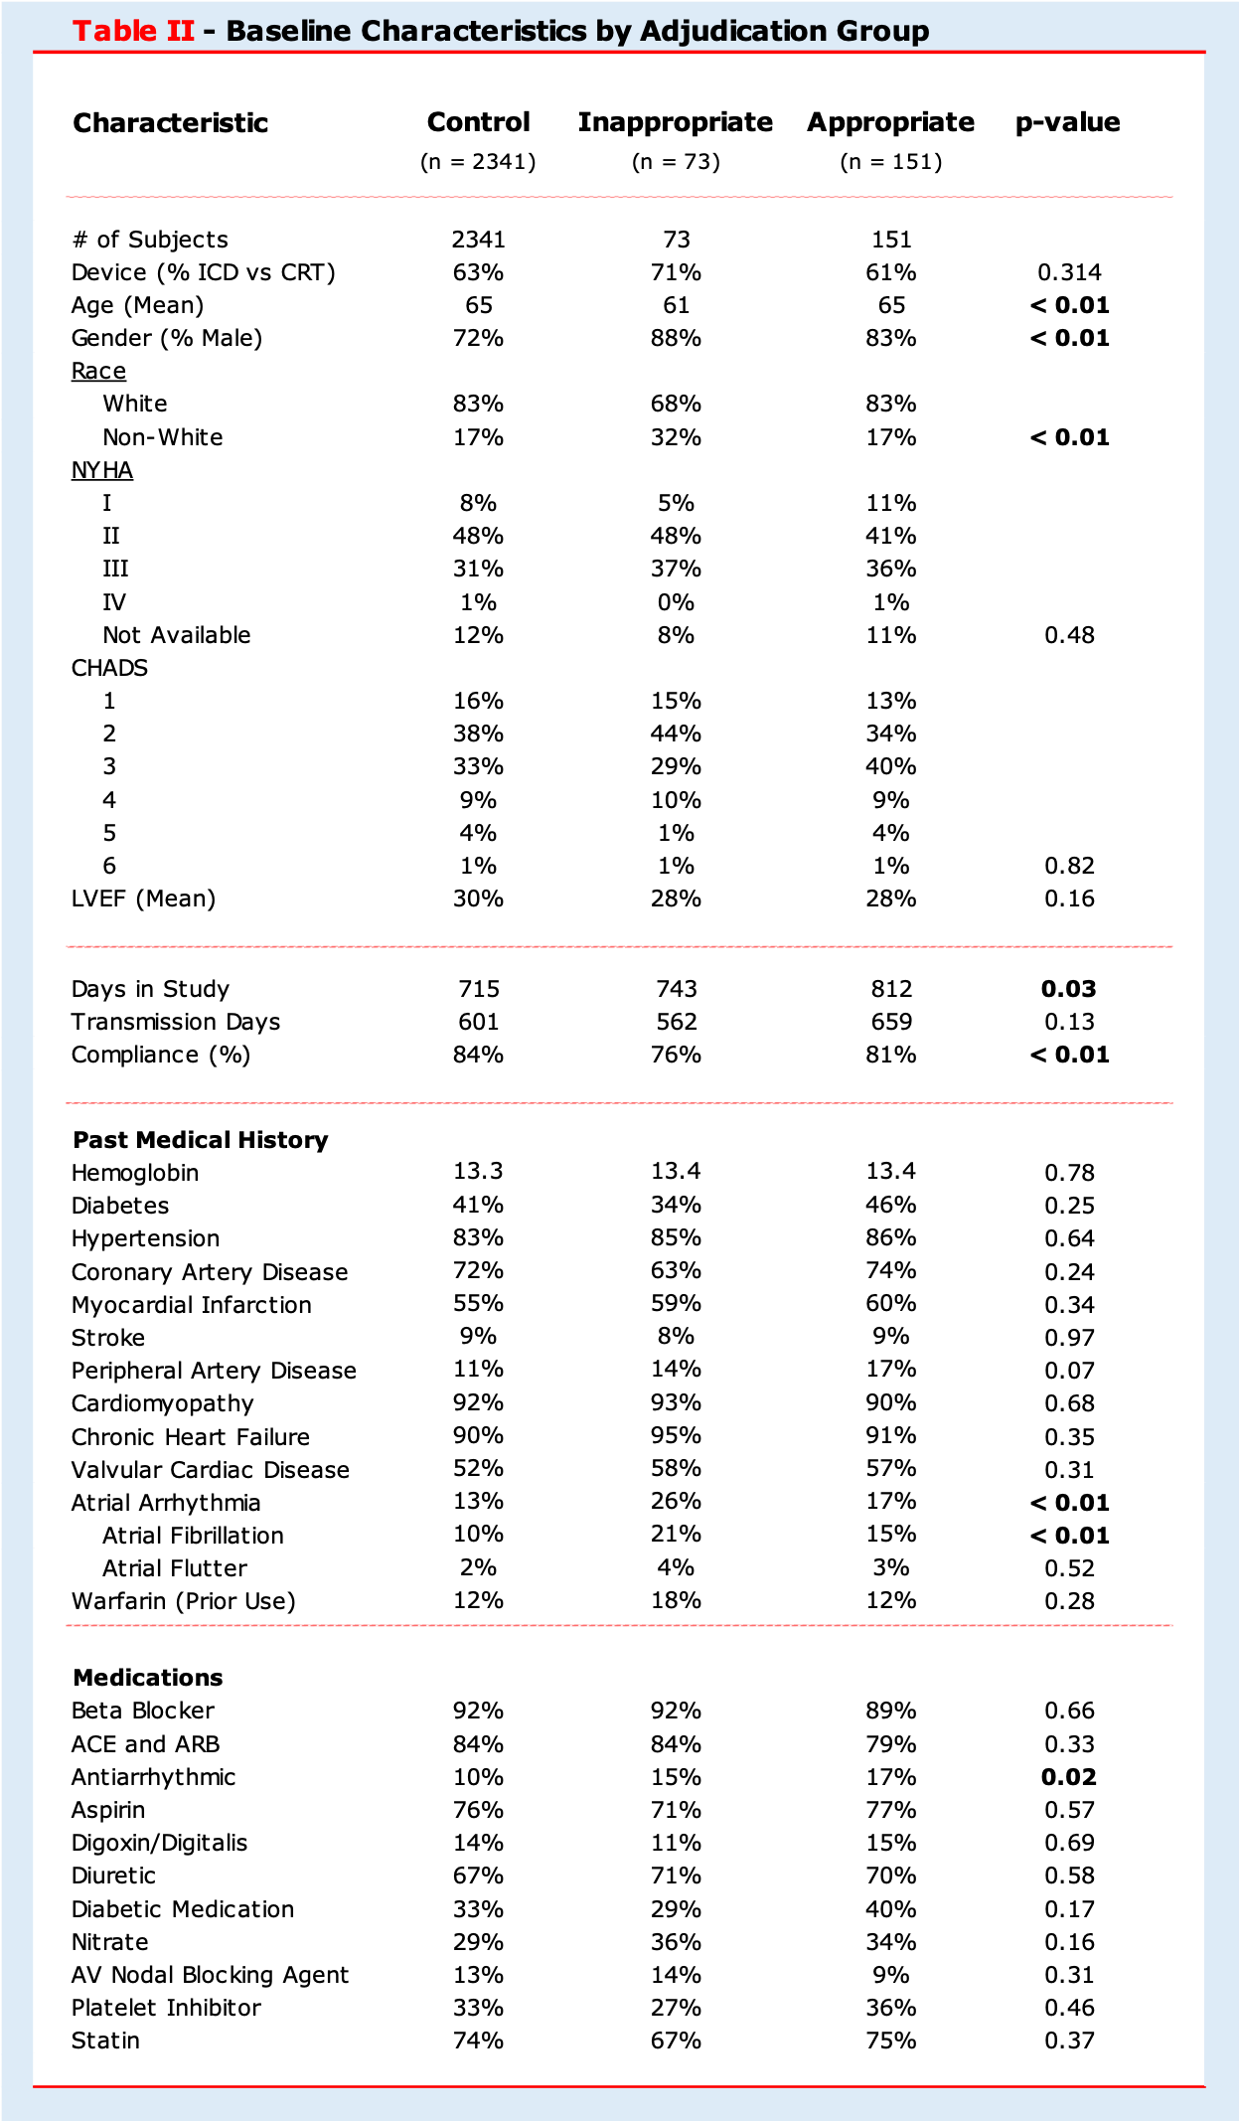

Table II - Baseline Characteristics by Adjudication Group. Statistical differences between adjudication groups were tested with Pearson’s Chi-Squared testing (frequency variables) and ANOVA (continuous variables). Patients with excluded EGMs were not included in analysis.

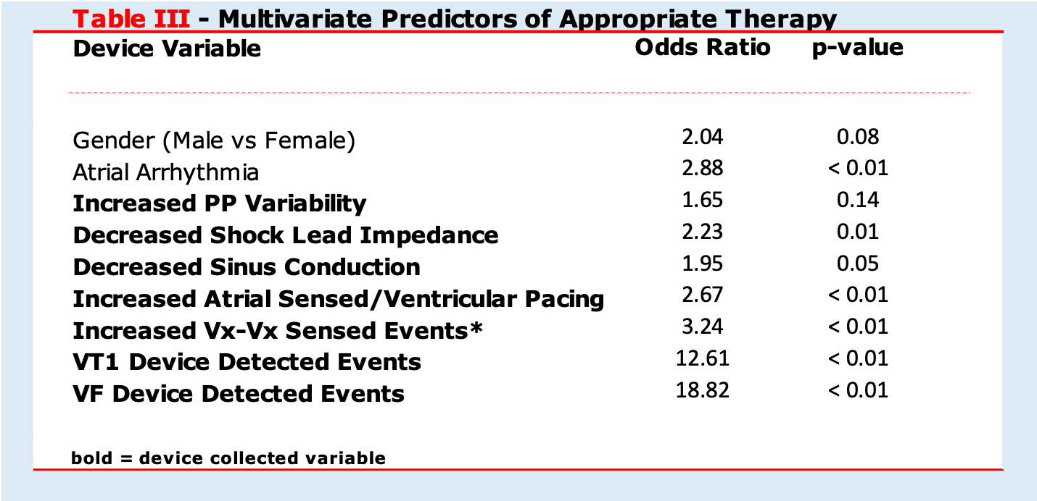

Table III - Multivariate Predictors of Appropriate Device Therapy. Two demographic and seven device collected variables were selected by stepwise logistic regression. Vx-Vx Sensed Event counts were defined by the device manufacturer as two consecutive ventricular events without an interceding atrial event.

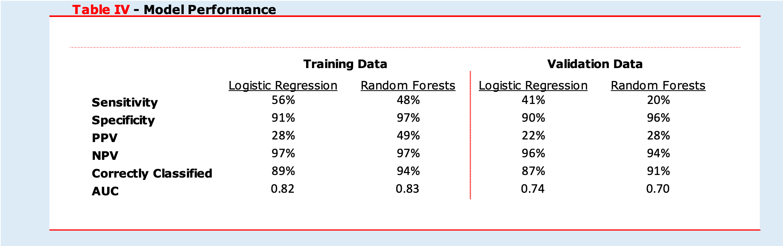

Table IV - Model performance comparison between multivariate logistic regression and random forest modeling on in-sample training data and out-of-sample validation data. Both models resulted in a high negative predictive value and correctly classified rate.

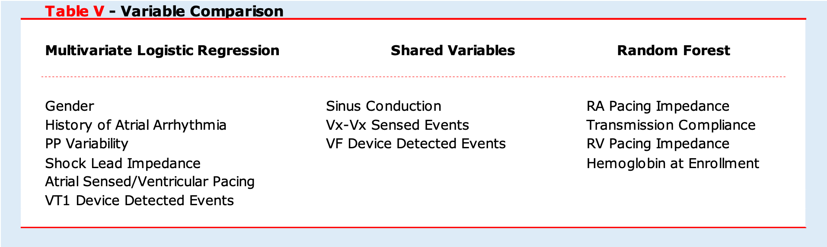

Table V - Variable Comparison. Placeholder text until the actual table is generated from Ishanu’s newer model.

**Figures**

**Figure I - In Sample and Out of Sample ROC Curves**

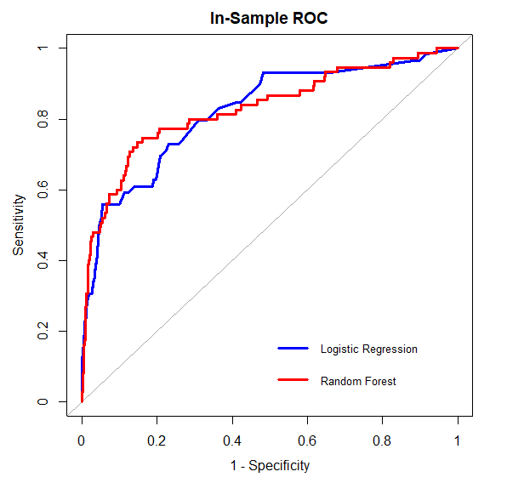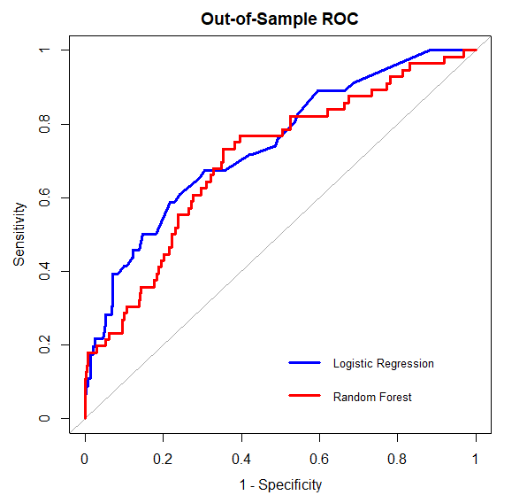

Figure I - Model performance was plotted using an ROC curve. Both models yielded similar performance on both in-sample training and out-of-sample testing data sets. To generate a highly specific model, a predicted probability cut-point of 5.8% was utilized.

**Supplemental Figures**

**Supplemental Figure I - Cutpoint Selection Methodology**

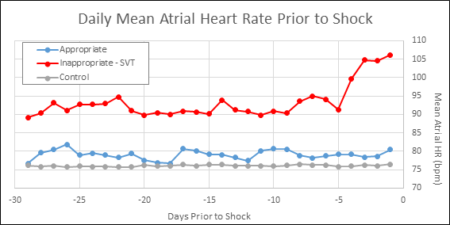

For each adjudication group, the average daily mean atrial heart rate (AHR) was obtained for each day prior to device therapy or monitoring endpoint. A trend towards increasing AHR was observed beginning 10 days prior to therapy for patients receiving inappropriate device therapy. The 10-day integral change in daily mean atrial heart rate over the baseline mean was calculated for each patient and plotted on a ROC curve, displayed below. Utilizing this ROC curve, a cut-point in 10-day integral change that yielded an 80% specificity in the prediction of inappropriate therapy was selected.

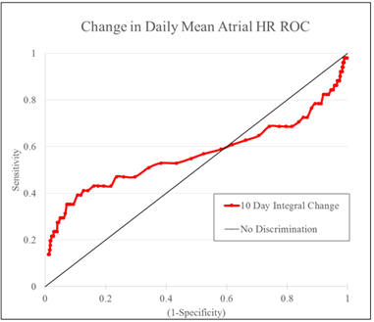

The selected cut-point corresponded to an average increase in AHR of 1.95 bpm over the 10 days prior to therapy. Patients with greater than a 1.95 bpm 10-day integral increase in AHR over their baseline AHR were counted as meeting the cut-point threshold, while patients with an integral change less than a 1.95 bpm increase were determined to not meet the threshold. Examples of each scenario are displayed below.

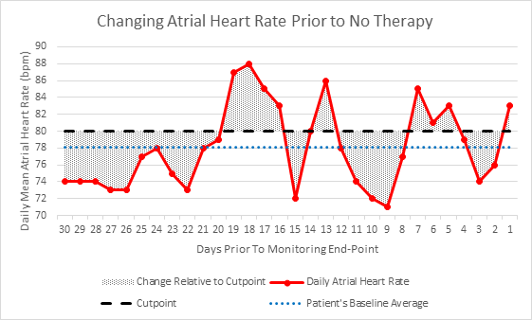

A patient not meeting the threshold for an increase in AHR is displayed above. The patient’s average baseline AHR was 78.07 bpm (blue dotted line), resulting in a cut-point threshold of 80.02 bpm (black dashed line) and a 10-day integral change of -1.92 bpm.

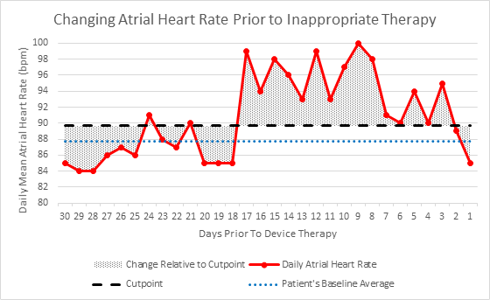

A patient meeting the threshold for an increase in AHR is displayed above. The patient’s baseline AHR was 87.73 bpm (blue dotted line), resulting in a cut-point of 89.68 bpm (black dashed line) and a 10-day integral change of 3.22 bpm.

**Supplemental Figure II - Device Diagnostic Cutpoints**

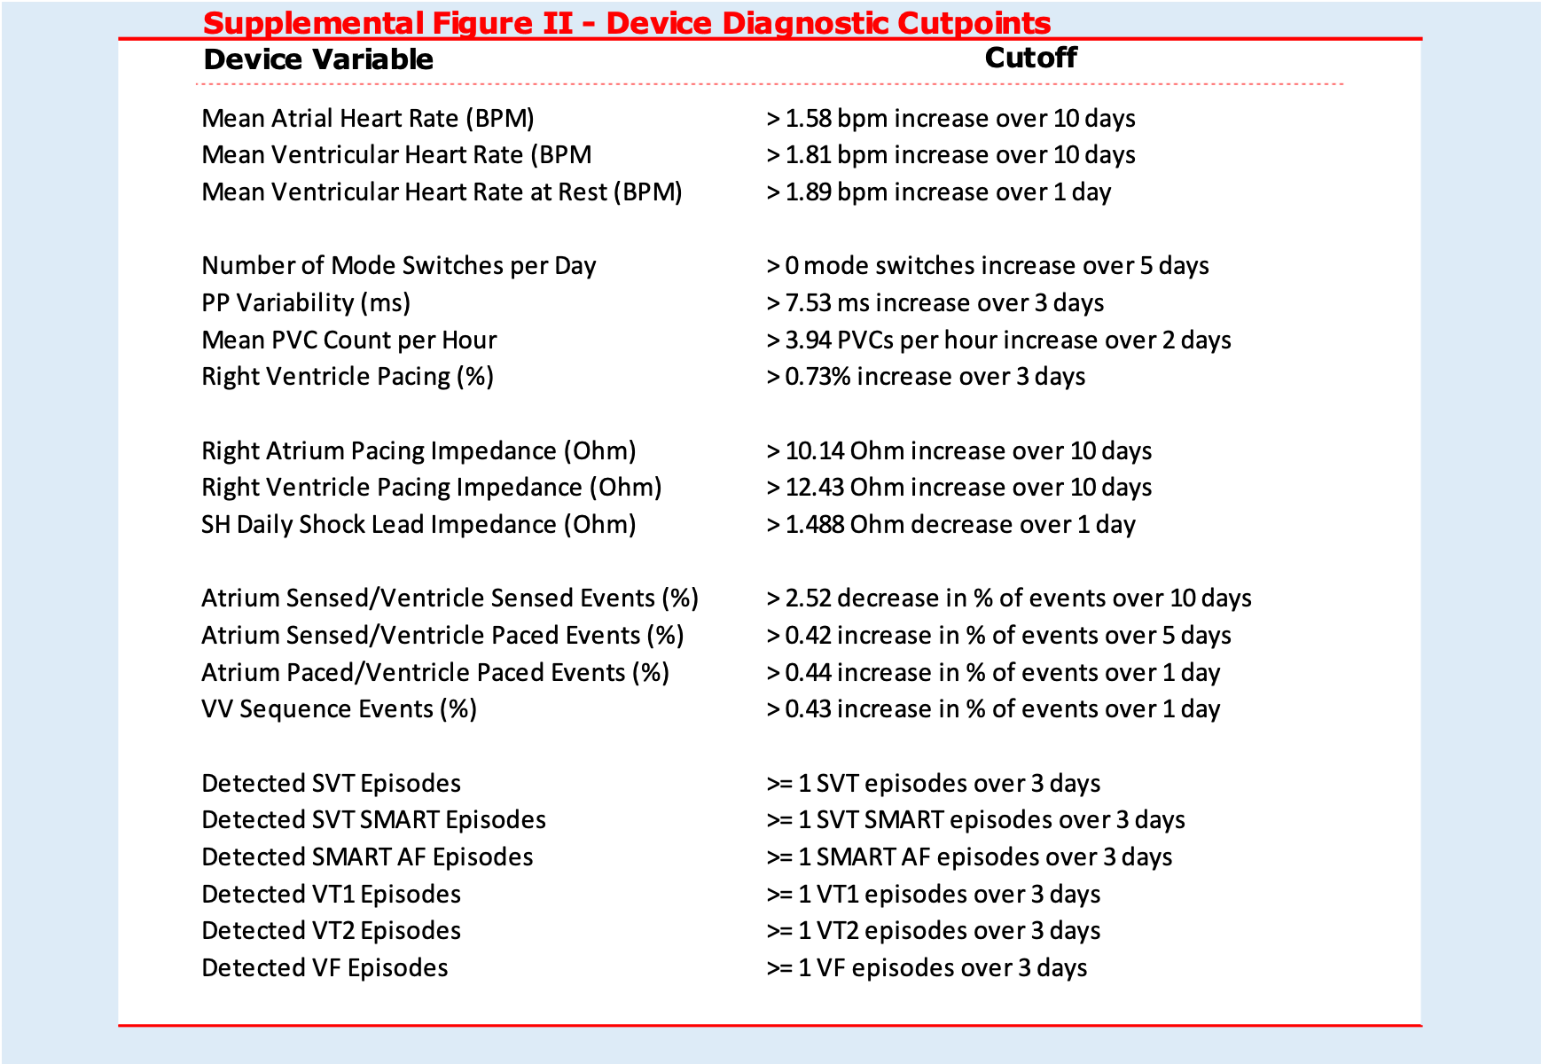Supplemental Figure II - Cutpoints for ICD variables measuring continuous data points were assigned using the methodology displayed in **Supplemental Figure I.** Device variables measuring count data (e.g. device detected arrhythmia events) were included as meeting a positive cut-point when an arrhythmia episode occurred within three days of device shock.

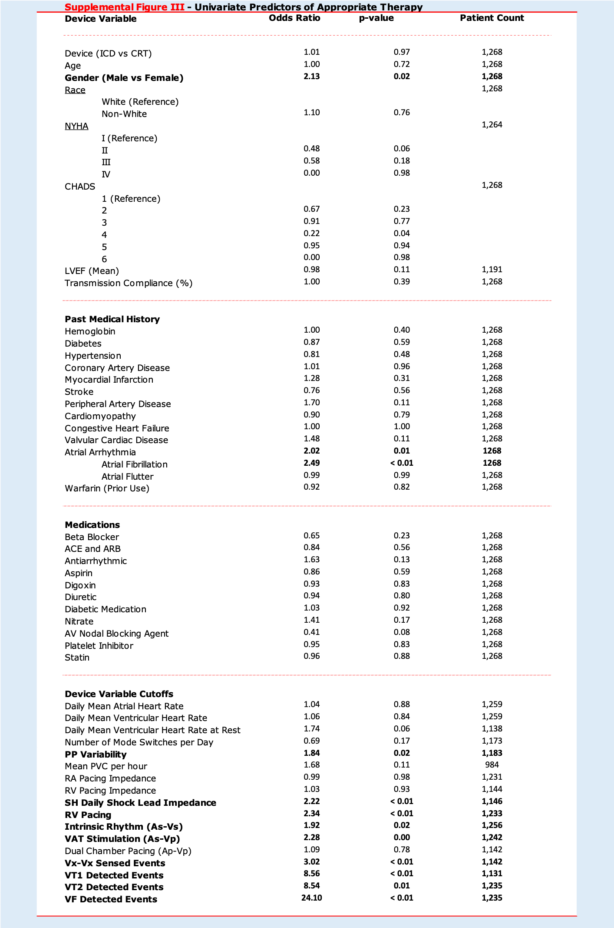**Supplemental Figure III - Univariate Logistic Regression, All Variables**

Supplemental Figure III - Univariate predictors of appropriate device therapy using logistic regression for patients included in the training data set. Demographic, medical history, and medications on trial enrollment were present for all patients. ICD settings were variable among patients and not all variable measurements were captured for each patient. The total count of patient devices storing each variable is displayed under patient count.

**Supplemental Figure IV - Univariate Logistic Regression, Significant Variables**

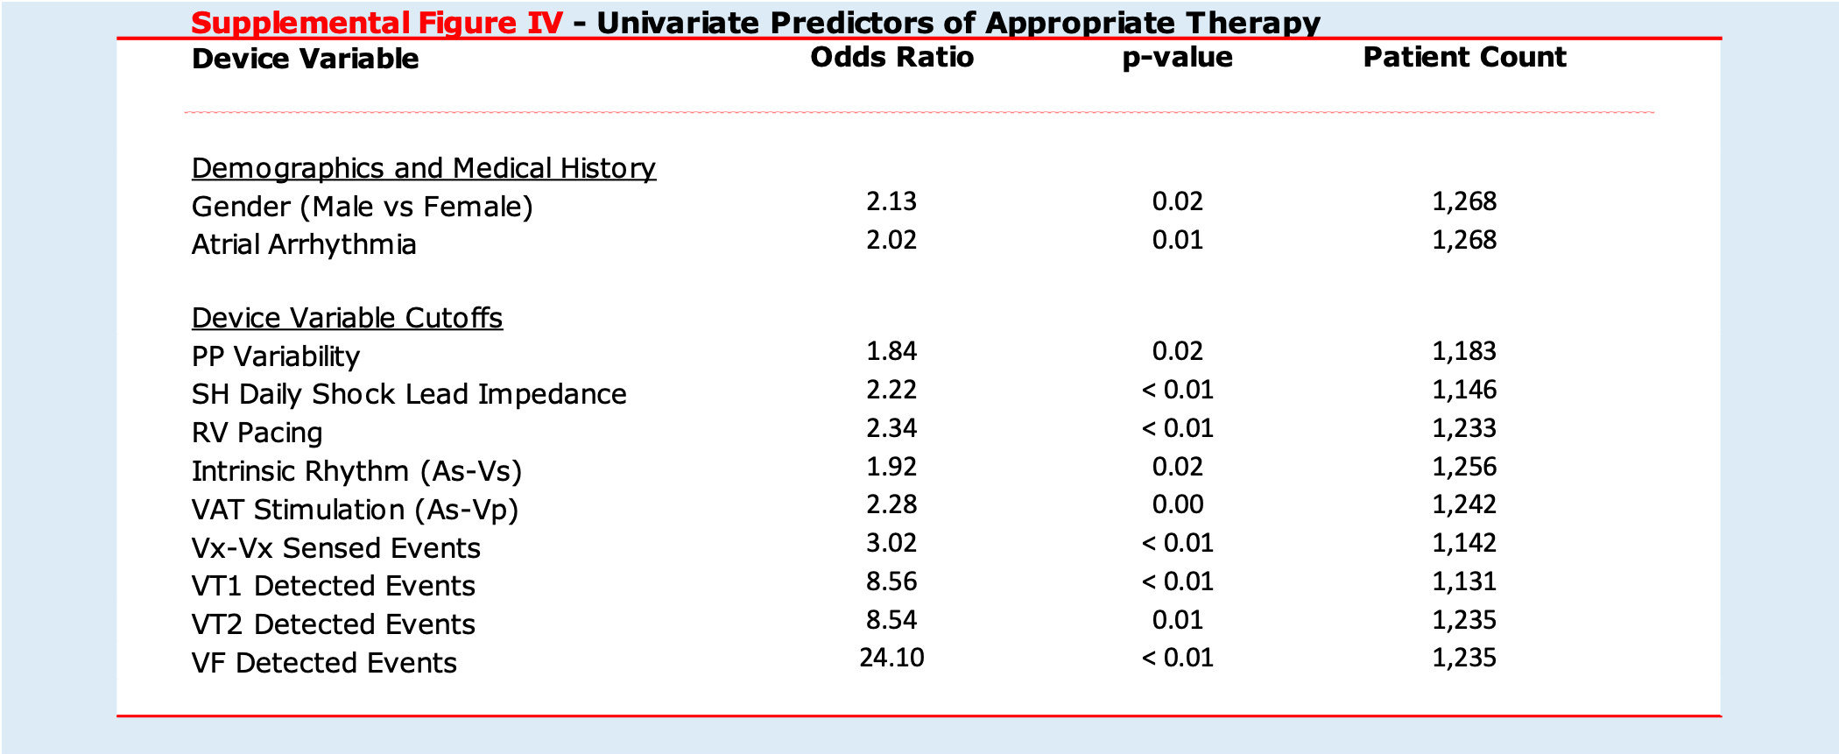

Supplemental Figure IV - Significant univariate predictors of appropriate device therapy.

**Appendix 5 - Random Forest Variable Importance Plot**

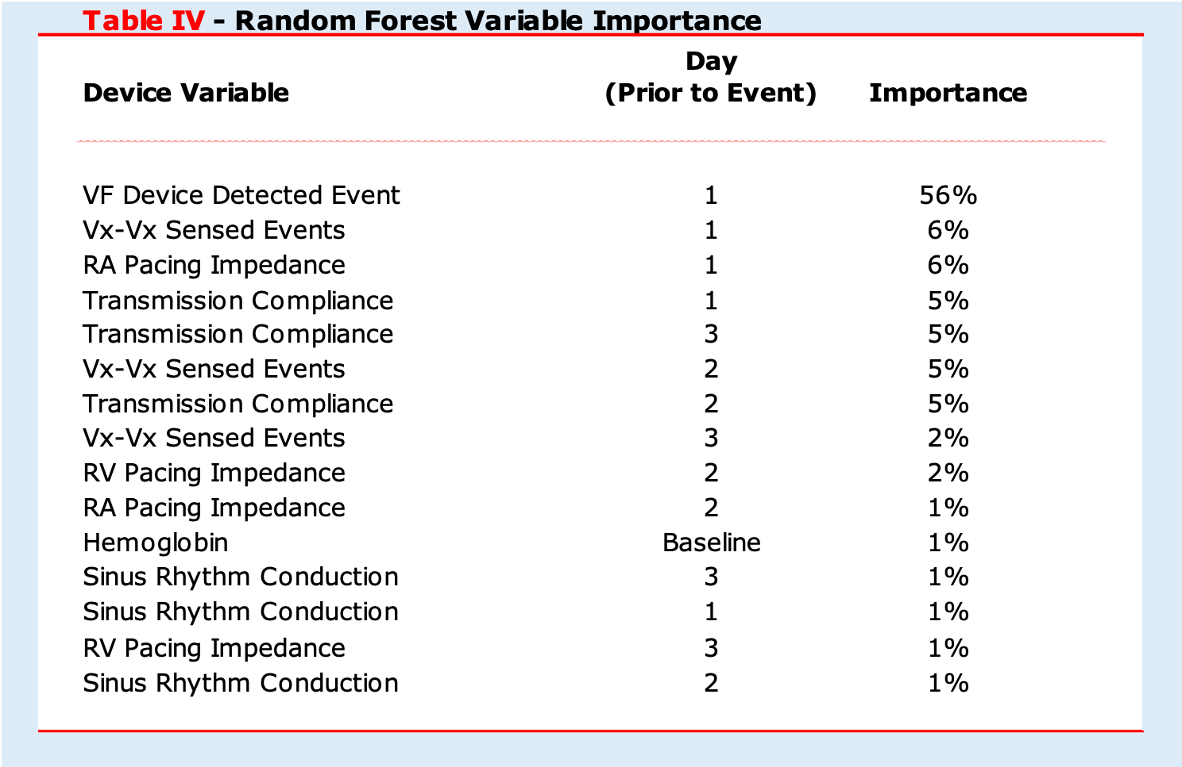

Appendix 5 - Random Forest Variable Importance. Device diagnostic variables for each day prior to enrollment midpoint (control patients) or device therapy (appropriately treated patients) were included in a random forest model. The relative measure of a variable importance was calculated using a Gini inpurity metric. The with a Gini impurity metric.

**Neural Network Model:**

**Preprocessing: We first removed data points that are computed within 10 days of the cardiac shock. Using the remaining data, we consider each feature from each day as an individual feature. Next, we split the data into a training and a testing set, where the testing set consists of 20% of the total data. We then replaced missing values in the training set with the mode values in each feature. We also replaced missing values in the testing set using the mode values we computed from the training set.**

**Model Training: We build a neural network model with three layers; the first layer has 128 hidden units, the second has 64 units, and the last layer has 2 units. The ReLU activation follows the first and second layer, and the softmax activation follows the last layer. In total, there are about 84,000 parameters. We use the ADAM optimizer with a learning rate of 0.001 to train the model for 20 epochs. During training, we reweighed the training instances based on their label frequency.**

**Model Evaluation: Evaluating the neural network on the test data, we achieved an accuracy of 93% and an ROC-AUC of 91.3%.**